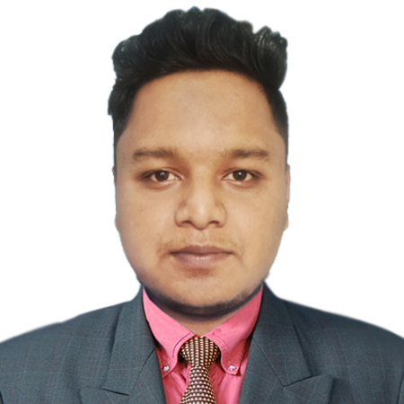 **CURRICULUM VITAE**

**OF**

BADHON KUMAR ROY

**Contact No:** 01783-147171

**E-mail:** **badhonroy172@gmail.com**

**Personal Information**

**Name** :Badhon Kumar Roy

**Father’s Name** : Bina Rani Roy

**Mother s Name** : Ranjit Roy

**Date of birth**  : 22 jan 2000

**Nationality** : Bangladeshi (By Birth)

**Marital Status** : Unmarried

**Height** : 5'7"

**Religion** : Hindu

**Sex** : Male

**Blood Group** : B(+)

**Permanent Address** : Vill:Sinduriya , Post:Deutirhat ,

Thana:Lalmonirhat , District:Lalmonirhat .

**Present Address** : Vill:Sinduriya , Post:Deutirhat ,

Thana:Lalmonirhat , District:Lalmonirhat .

**Professional Summary**

Software Engineer with foundational knowledge in PHP, JavaScript, and React, currently completing a BSc in CSE. Possessing a strong drive for learning and problem-solving, I aim to contribute to innovative projects in a challenging and dynamic team environment, fostering professional development and growth.

**Technical skills**

**Programming Languages:** PHP, JavaScript, **TypeScript**, SQL  
 **Frameworks & Libraries:** CodeIgniter, React  
 **Frontend Technologies:** HTML5, CSS3, Tailwind CSS, Bootstrap  
 **Backend & Database:** MySQL, Supabase, REST APIs, Ajax  
 **Tools & Technologies:** Git, Docker, Linux, cPanel

**Educational Qualification**

**Bsc in CSE:**

University : World University of Bangladesh

Subject : CSE

Passing Year : Running

**Diploma in Engineering (Computer):**

Institute : Kurigram Polytechnic Institute, Kurigram.

Subject : Computer

Season : 2017-18

Passing Year : 2022

Semester :Eight

Result : 2.84

**Secondary School Certificate:**

School :Deutirhat High School

Year : 2017

Board : Dinajpur

Result : G.P.A 4.45 (on scale of 5)

**Language Communication**

Efficient in English & Bengali, Both in Speaking and Writing.

**Online Portfolio**

Personal portfolio website to showcase projects and skills.

**Link:** badhonprotfolio.netlify.app

**Professional Experience**

01 Decmber 2022 - Present

Software Engineer

Solution Hub Technologies

Badhon

**Signature**

